1.Project Title
“Object-Oriented Online Voting System using Java” is a secure and efficient application designed to conduct digital elections. The project ensures transparency and fairness by integrating features such as voter authentication, candidate registration, and real-time vote counting. Built with modular coding and OOP principles, it emphasizes scalability, maintainability, and ease of use. The system provides a user-friendly interface for voters while safeguarding data integrity through validation and error handling. This project demonstrates how Java can be applied to solve real-world problems with accuracy and reliability.

NAME – ANKIT KUMAR PASWAN
ERP – RU-25-10214
COURSE / BRANCH – B.TECH / CSE(AI/ML)
SUBMISSION DATE – 15/04/26

Acknowlexgement
Thanks Faculty Shivansh Mehta.

Introduction
The “Object-Oriented Online Voting System using Java” is a modern application designed to replace traditional paper-based voting with a secure and efficient digital platform. Voting is a critical process in any organization or institution, and this project addresses the need for transparency, speed, and reliability in conducting elections. Built using Java and object-oriented programming principles, the system ensures modularity, scalability, and ease of maintenance.
The project provides features such as voter authentication, candidate registration, secure login, and real-time vote counting. It prevents duplicate voting and ensures that only eligible voters can participate. The system also offers a user-friendly interface, making it accessible to both administrators and voters. By minimizing human intervention, it reduces errors and enhances trust in the election process.
Overall, this project demonstrates how technology can modernize voting systems, ensuring fairness, accuracy, and efficiency while serving as a practical example of applying Java to solve real-world problems.

Abstarct
The project titled “Object-Oriented Online Voting System using Java” is designed to provide a secure, transparent, and efficient platform for conducting digital elections. In today’s world, where manual voting processes are often time-consuming, prone to errors, and vulnerable to manipulation, an online voting system is a much-needed solution. It addresses the growing demand for reliable digital platforms that can ensure fairness, accessibility, and accuracy in the voting process.
This system allows registered voters to cast their votes electronically after proper authentication, ensuring that only eligible participants can take part. It includes features such as candidate registration, secure login, vote casting, and real-time vote counting. By leveraging Java’s object-oriented programming principles, the project emphasizes modularity, scalability, and maintainability, making it adaptable for different institutions or organizations.
The Online Voting System not only reduces logistical challenges but also enhances transparency by minimizing human intervention. It provides a user-friendly interface, safeguards data integrity, and ensures that results are generated quickly and accurately. Overall, this project demonstrates how technology can modernize traditional voting methods, making elections more accessible, secure, and trustworthy.

Objectives
The primary objective of the “Object-Oriented Online Voting System using Java” is to provide a secure, efficient, and transparent platform for conducting elections digitally. The system manages voter and candidate records systematically, ensuring that all data is stored and retrieved accurately. It reduces manual work by eliminating paper ballots, physical counting, and human errors, thereby saving time and resources. The project applies Object-Oriented Programming (OOP) concepts such as encapsulation, inheritance, and modular design to make the system scalable and easy to maintain.
It ensures proper voter authentication to prevent duplicate or unauthorized voting. The system also provides real-time vote counting and instant result generation, enhancing transparency and trust in the process. With a user-friendly interface, it simplifies the voting experience for both administrators and voters. Overall, the objective is to modernize traditional voting methods, reduce manual workload, and demonstrate the practical application of Java and OOP principles in solving real-world problem

Scope :
The “Object-Oriented Online Voting System using Java” has wide applicability in educational institutions, organizations, and even larger communities where elections are conducted. Its scope lies in managing voter and candidate records efficiently, ensuring that data is stored securely and retrieved accurately when needed. By reducing manual work such as paper ballots, physical vote counting, and human verification, the system saves time and minimizes errors. The integration of Object-Oriented Programming concepts makes the project modular, scalable, and easy to maintain, allowing future developers to extend its functionality.
In the future, this system can be integrated with biometric authentication, cloud-based storage, and mobile applications to enhance accessibility and security. It can also be adapted for large-scale elections by incorporating encryption techniques and distributed databases. The project demonstrates how technology can modernize traditional voting methods, making them more transparent, reliable, and suitable for integration into digital governance frameworks.

System Requirements:
To run the “Object-Oriented Online Voting System using Java”, the following hardware and software requirements are necessary:
- Hardware Requirements:
  - Processor: Intel i3 or higher
  - RAM: Minimum 4 GB (8 GB recommended)
  - Hard Disk: At least 500 MB free space
  - Display: Standard resolution (1024x768 or higher)
- Software Requirements:
- Operating System: Windows 10/11, Linux, or macOS
- Programming Language: Java (JDK 8 or above)
- IDE/Editor: Eclipse, NetBeans, or VS Code
- Database: MySQL or any relational database for storing voter and candidate records
- Additional Tools: JDBC driver for database connectivity

Methodology :
- Voter Registration: The system begins with adding new voters into the database. Each voter is assigned a unique ID and credentials to ensure authenticity.
- Candidate Registration: Administrators can add candidate details such as name, party, and other relevant information into the system.
- Authentication Process: When a voter logs in, the system verifies their credentials to prevent duplicate or unauthorized voting.
- Search Functionality: The system allows administrators to search for voter or candidate records quickly using unique IDs or names.
- Modification of Records: If any voter or candidate details need updating, the system provides options to edit or modify records securely.
- Vote Casting: Once authenticated, voters can cast their vote electronically, which is stored in the database.
- Real-Time Counting: Votes are automatically counted by the system, reducing manual work and ensuring accuracy.
- Result Generation: The system generates instant results after voting ends, displaying the total votes for each candidate.
- Data Security: All records are protected with validation checks to maintain integrity and prevent tampering.
- Application of OOP Concepts: Encapsulation secures data, inheritance allows code reusability, and modular design ensures scalability for future enhancements.

Flowchart :
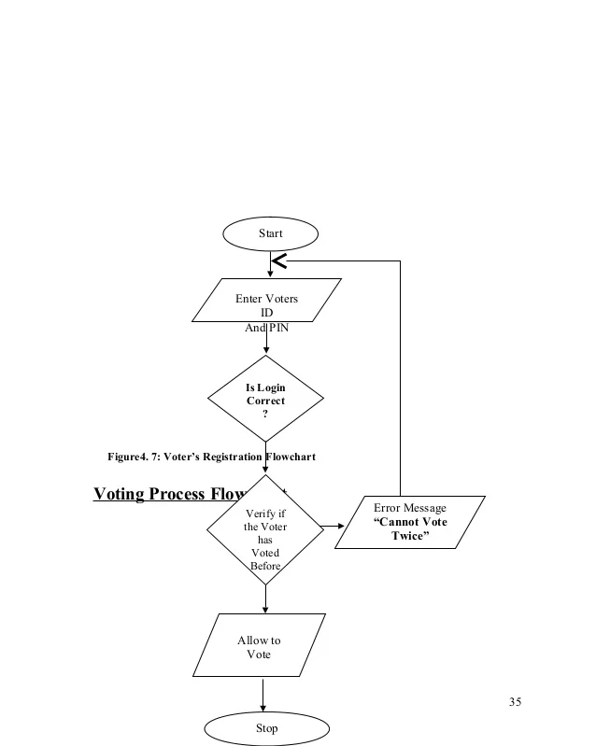

Implementation :
The project is structured using Object-Oriented Programming (OOP) principles, where each class represents a specific component of the system. The Voter class handles all voter-related operations such as registration, authentication, and vote casting. It stores individual voter details and ensures that each voter can vote only once.
The Candidate class manages candidate information including name, party, and vote count. When a vote is cast, the system updates the candidate’s vote count automatically.
The VotingSystem class acts as the central controller, coordinating interactions between voters and candidates. It maintains arrays or lists (like ArrayList and ArrayList) to store multiple records efficiently. This class provides methods to add, search, modify, and display data, ensuring smooth workflow and data integrity.
The logic follows a modular approach — each class performs its own task, and together they form a cohesive system. This structure reduces redundancy, improves maintainability, and makes future integration (like adding new features or connecting to a database) straightforward.

Future Enhancements :
- Biometric Authentication: Integrate fingerprint or facial recognition to ensure secure voter identification and prevent impersonation.
- Cloud Integration: Store voter and candidate records in cloud databases for scalability, accessibility, and backup.
- Mobile Application Support: Develop Android/iOS apps so voters can cast votes conveniently from smartphones.
- Encryption & Blockchain: Use advanced encryption or blockchain technology to secure votes and ensure tamper-proof records.
- Multi-Language Support: Add language options to make the system accessible to diverse users.
- Real-Time Analytics: Provide dashboards for administrators to monitor turnout, voting trends, and system performance.
- Scalability for Large Elections: Adapt the system to handle thousands or millions of voters efficiently.
- Role-Based Access Control: Differentiate permissions for administrators, voters, and auditors to enhance security.
- Integration with Government Databases: Link with official voter ID databases for automatic verification.
- Audit Trail & Reporting: Maintain logs of all activities for transparency and post-election analysis.

Conclusion :
The “Object-Oriented Online Voting System using Java” successfully demonstrates the practical application of Java programming and Object-Oriented Programming (OOP) concepts. By dividing the system into classes such as Voter, Candidate, and VotingSystem, the project highlights modularity, encapsulation, and scalability. Each class performs its own responsibilities, yet they work together seamlessly to create a functional and reliable system.
The project achieves its goal of reducing manual work by automating voter registration, candidate management, vote casting, and result generation. It ensures data integrity, transparency, and efficiency, making the voting process faster and more secure. The use of arrays and collections for managing records shows how Java can handle real-world data effectively

Reference :
create Java documentation using Javadoc comments in your code and generate HTML docs with the JDK tool, while learning from Oracle Java Documentation, W3Schools tutorials, and textbooks like Head First Java or Java:

